Major Mastitis Pathogen Isolation and Treatment Guidelines

Philip Sears
MSU Department of Large Animal Clinical Science

Over the years, many methods of milk culturing have been employed to provide information on mastitis prevention, treatment and control. In general, these efforts have centered on culturing in a laboratory located at a university, milk processor, or veterinary clinic. By the time culture results of clinical infections are reported back from laboratories to the dairy, too much time has elapsed to be of value for treatment decisions. The attached slide presentation was designed to help personnel in small laboratories in veterinary hospitals or on farms make appropriate diagnosis of mastitis causing bacteria that can help direct mastitis treatment decisions.

I would like to re-emphasize a couple points made in this presentation and provide you with an on-farm protocol to use in this type of treatment/control program. The person(s) responsible for on-farm culturing must be interested and have enough of a background for training. It is most useful if it is the same person who is responsible for treating clinical cases of mastitis. On-farm culture is often perceived as the way to treat and clinical cases, however once the procedure has been established, subclinical mastitis cases can be managed in a similar fashion. Culturing cows with high somatic cell counts or infections at calving can utilize the same diagnostic information for making treatment and control decisions. Knowing when not to treat can be as valuable as knowing who to treat.

On-farm milk culturing can be a viable and useful tool for improving treatment protocols and overall milk quality. The success or failure of these programs is highly dependent upon the motivations, training and support of the personnel involved in this activity. The materials necessary are easily obtained, economical, and reasonably straightforward to use with proper training. Information derived from culturing is valuable for its timeliness in identification and treatment of mastitis pathogens, as well as its usefulness in the development of control strategies. Overall success is a function of the commitment and motivation of the personnel in charge of culturing.

I have included excerpts from our Mastitis Pathogen Isolation and Treatment Guidelines that shows some of the procedures discussed in this presentation. A complete guideline, protocol for on-farm milk culturing with color photos and sources of supplies can be found in the “Major Mastitis Pathogen Isolation and Treatment Guideline” (brochure) or at www.cvm.msu.edu/~sears/isolation.htm .

On-farm milk sampling and culture procedures

Milk samples must be taken using aseptic technique and placed on ice or refrigerated immediately. Contaminated samples or mishandling of the sample can lead to misdiagnosis and confusion.

Sample consideration:
Individual: Composite samples used to screen herd for infected cows.
Quarter samples when evaluating individual or clinical cows.

Bulk Tank: Screen herds for contagious mastitis (Strep ag, Staph aureus, Mycoplasma)

Sampling:Clean teats (predip and dry) before sampling.
Clean teat end with 70% alcohol using cotton balls, pledgets or wipes.
Teats must be dry before collection sample. Use a tight sealing vial or tube.
Discard first milk and collect (45o angle) into a sterile vial or tube (5 to 10 ml).
Store sample on ice or refrigerate until plating. (Freeze, if greater than 48 hours).

Plating Selective Agar:
Plate milk sample as soon after collecting as possible. Fresh is best.
Single plate media (blood agar plates) can be quartered for a cow or half for composites.
Selective agar bi-plate (Blood agar and MacConkey agar): plate clinical quarter per plate.
Read selective media first:
• MacConkey agar selective for coliforms
• Blood agar will grow all organisms
Gram Stain and other tests are helpful in identifying organisms.

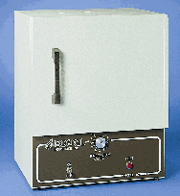
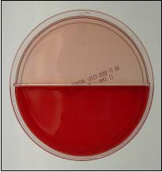

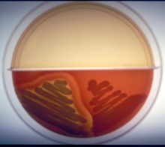
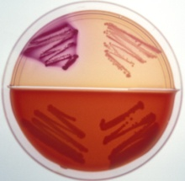
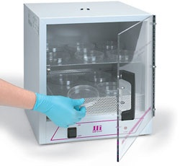
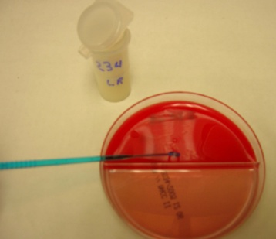
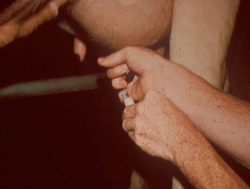
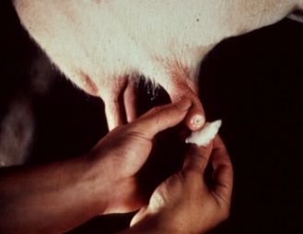
Laboratory
Supplies
Milk Culture Procedures
Gram-positive
infection
Gram-negative
infection
37º C
Incubator
Loops
Bi-plate
Identify the
infection
Incubate plate
for 18-24 hours
Streak milk onto
agar bi-plate
Collect mastitis
milk sample
* Spectramast is available and may prevent chronic IMI *NSAID - Non-steroidal anti-inflammatory drugs
Monitor
Fever
NSAID, if
No Antibiotics
No Growth
Monitor
Fever
NSAID, if
No Antibiotics
Coliform
antibiotic
therapy
Intramammary
Envir Strep
Evaluate Cow

1. Return to milk
2. Eliminate quarter
3. Cull cow
2. Monitor
1. Await Culture
Mastitis Pen
3. Monitor
2. Oral Fluids
1. NSAID
Boxstall
CNS
Staph
Intramammary
antibiotics
Flag records
Fever
Strep
Ag
Intramammary
antibiotic
Treat all 4
qrts
Flag records
Staph aureus
Intramammary
antibiotics
Flag records
Cull?
No Fever
Physical
Exam
Culture
Cow
Mastitis
Clinical
Strep spp: Susceptibility testing
Identify new cases:
Intramammary antibiotics
(Systemic antibiotic - IM)
Sick:
No antibiotic IMM (low cfu)
IMM antibiotic* (high cfu)
NSAID & fluids as needed
Sick: (fever, dehydrated)
NSAID – Banamine, etc
(Non-steroidal anti-inflammatory drugs)
fluids (IV or Oral)
Staph aureus: Susceptibility testing
New cases: heifers and early infections
Intramammary antibiotics → Segregrate
Extended therapy (3 to 8 days treatment)
Systemic antibiotic (IM)
Chronic IMI: non-responsive to antibiotics → Cull
Staph spp: Susceptibility testing
New cases: heifers and early infections
Intramammary antibiotics
Extended therapy (3 to 8 days treatment)
Systemic antibiotic (IM)
Clinical Mastitis
Pathogen
Treatment based on symptom and culture isolation

Not Sick:
No antibiotics (IMM)

Not Sick:
No antibiotic IMM (low cfu)
IMM antibiotic* (high cfu)

Strep agalactiae
Strep ag is a herd problem and should be eliminated from the herd. Culture & treat all positive cows.

therapy
antibiotic
Intramammary
Strep spp
No Growth
Monitor
Fever
NSAID, if
No Antibiotics
Clinical Mastitis Therapy - Guidelines

Staph spp
Intramammary
antibiotics
Flag records
Coliform
No Antibiotics
NSAID, if
Fever
Monitor

